Linux file permission illustrated.  
.

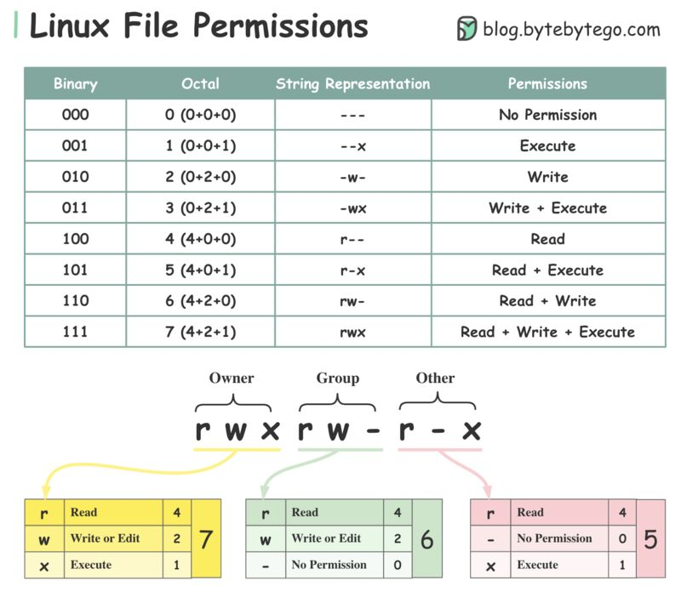  
.  
To understand Linux file permissions, we need to understand Ownership and Permission.  
  
𝐎𝐰𝐧𝐞𝐫𝐬𝐡𝐢𝐩  
Every file or directory is assigned 3 types of owner:  
  
🔹Owner: the owner is the user who created the file or directory.  
🔹Group: a group can have multiple users. All users in the group have the same permissions to access the file or directory.  
🔹Other: other means those users who are not owners or members of the group.  
  
𝐏𝐞𝐫𝐦𝐢𝐬𝐬𝐢𝐨𝐧  
There are only three types of permissions for a file or directory.  
  
🔹Read (r): the read permission allows the user to read a file.  
🔹Write (w): the write permission allows the user to change the content of the file.  
🔹Execute (x): the execute permission allows a file to be executed.   
  
Over to you: what are some of the commonly used Linux commands to change file permissions?  
  
—  
This week’s newsletter-only topic is “𝐖𝐡𝐚𝐭 𝐝𝐨 𝐖𝐡𝐚𝐭𝐬𝐀𝐩𝐩, 𝐃𝐢𝐬𝐜𝐨𝐫𝐝, 𝐚𝐧𝐝 𝐅𝐚𝐜𝐞𝐛𝐨𝐨𝐤 𝐌𝐞𝐬𝐬𝐞𝐧𝐠𝐞𝐫 𝐡𝐚𝐯𝐞 𝐢𝐧 𝐜𝐨𝐦𝐦𝐨𝐧?”. If you don’t want to miss it, subscribe to the ByteByteGo newsletter at <https://bit.ly/3FEGliw> It will be sent out on Saturday.  
   
[#systemdesign](https://www.linkedin.com/feed/hashtag/?keywords=systemdesign&highlightedUpdateUrns=urn%3Ali%3Aactivity%3A6937790471083581440) [#coding](https://www.linkedin.com/feed/hashtag/?keywords=coding&highlightedUpdateUrns=urn%3Ali%3Aactivity%3A6937790471083581440) [#interviewtips](https://www.linkedin.com/feed/hashtag/?keywords=interviewtips&highlightedUpdateUrns=urn%3Ali%3Aactivity%3A6937790471083581440)  
.